**Introduction**

Present your topic. Why is it important, e.g., what societal applications would benefit? What are the challenges in building? Include pictures to illustrate the challenges.

**Previous Work**

**Design and Implementation**

Describe the dataset: number of images, number of object classes, any interesting properties of the dataset. Show some example images. Don't forget to present the evaluation metric.

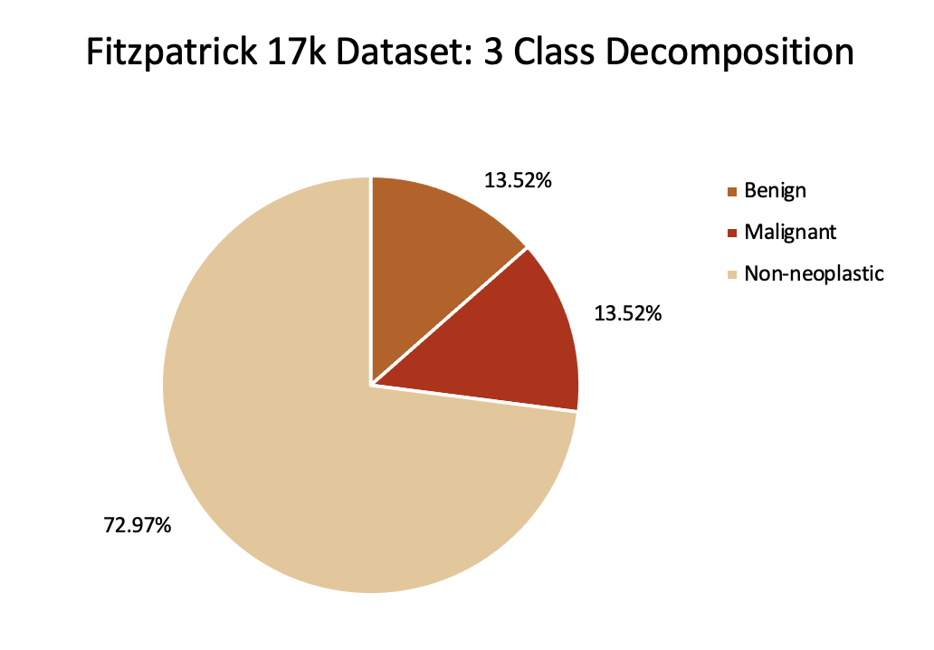

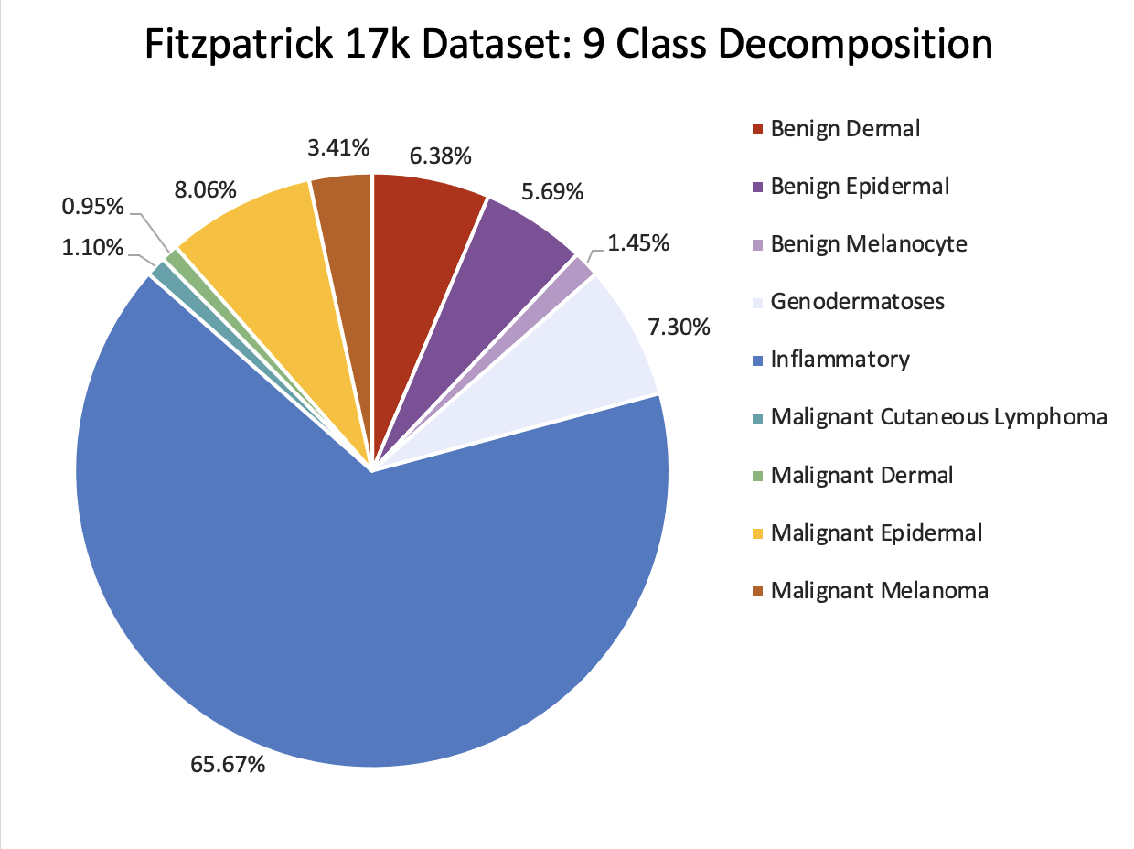

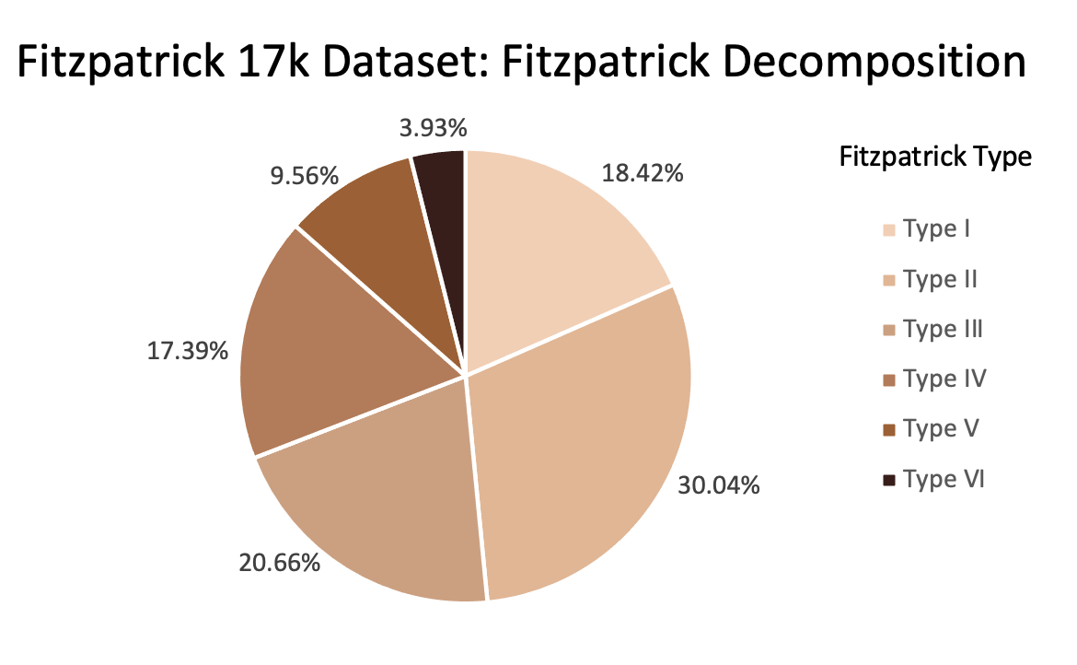

Image examples from each class

Describe CNNs as if you were teaching 429 lecture

* Continue to train a pre-trained ResNet CNN on new data
  + Train with 3 and 9 object classes
  + Train either the entire network or only the FC layer
* Evaluate the trained model for each of the 6 Fitzpatrick skin types

**Results**

* Predicting (non-)neoplastic conditions (the 3 class CNN) was very effective (all skin types > 80% accuracy on the regular dataset)
* Predicting more fine grained conditions (the 9 class CNN) was also quite effective (all skin types > 75% accuracy on the regular dataset)
* Model was most accurate for skin types III, IV, and VI
  + Inconsistent with the number of images of each skin type (see dataset decomposition in the Methods section)
  + Likely due to an relatively overwhelming number of images in one category, leading the model toward predicting that label almost all of the time (see confusion matrices)
* Balancing the dataset did not yield different ratios
  + “Balanced” dataset balances by removing images
  + “Augmented” dataset balances by copying and randomly rotating images

Present your analysis, including any hypotheses, intuitions or surprises, backed by both quantitative and qualitative results. This is the core of your work: make sure the reader walks away with a much more in-depth understanding of the challenge and of the strengths and weaknesses.

In Analysis, make sure to answer following questions: What are your goals? Why did you make the design choices that you made? What did you think would happen as a result? Is this in fact what happened? If the results did not align with your intuition, why was that? In the end, what did your system do well? Where did it fail? Why? What are the steps to improve it? What have you learned about computer vision along the way?

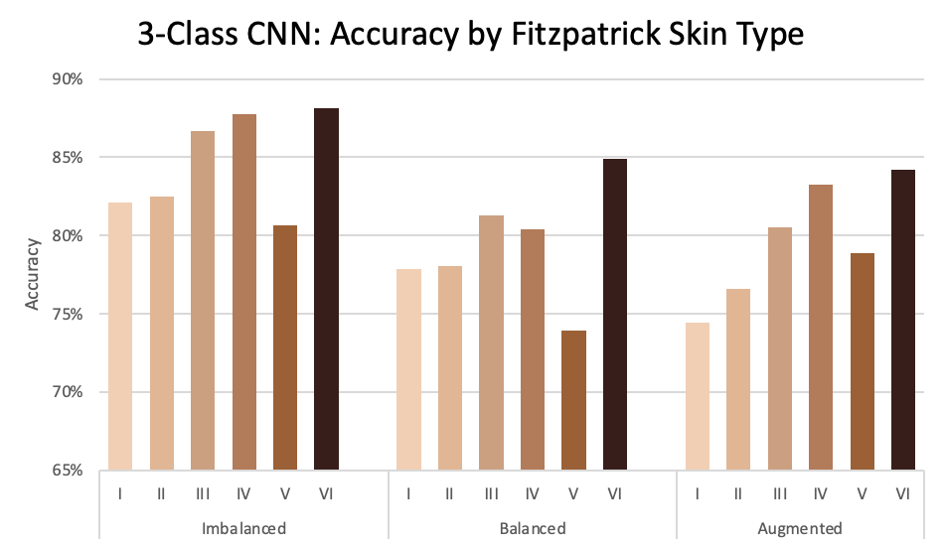

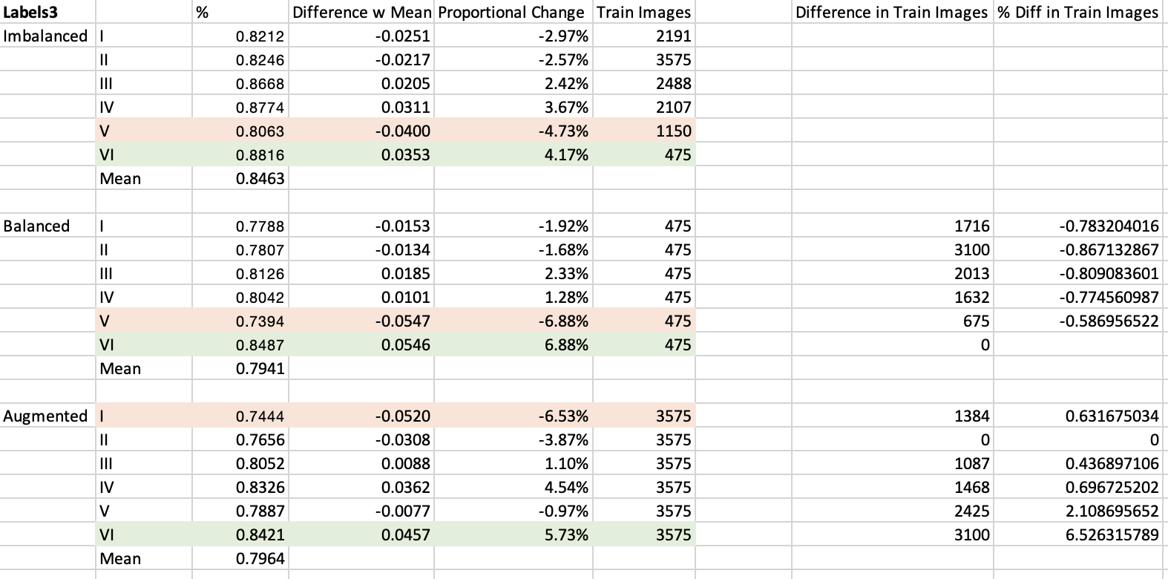

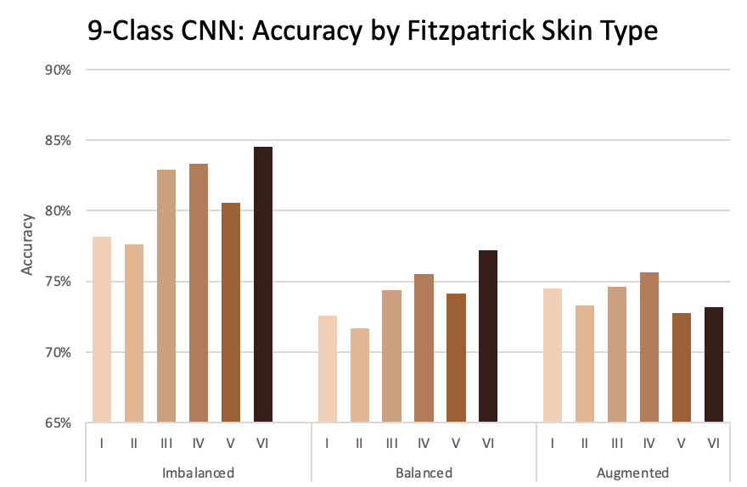

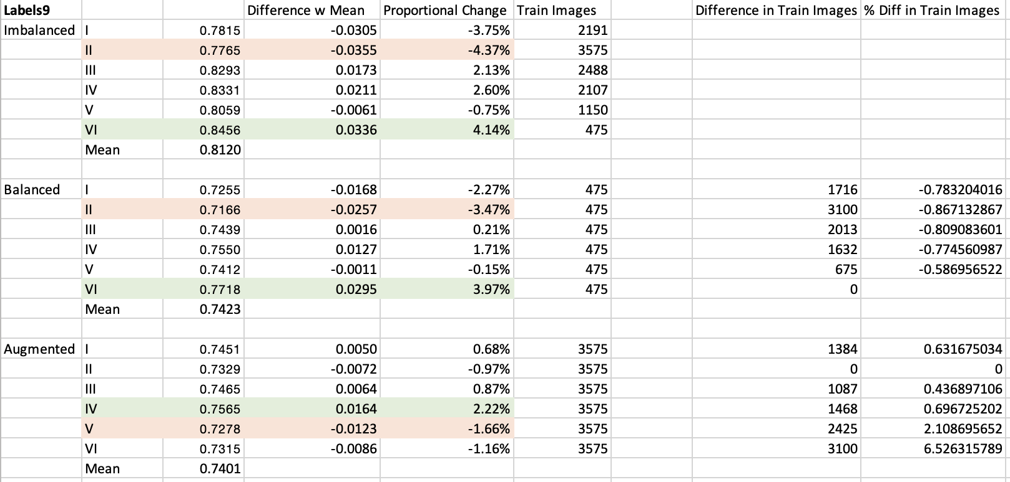

**Discussion**

strengths and weaknesses of implementation

Describe your modification(s) to the method, and the resulting quantitative and qualitative changes. If the modification(s) did not improve the method as expected, discuss some reasons for why this might be the case.

* Results are tentatively promising: smaller sub-datasets do not necessarily guarantee poor performance
* Disparity in ratio of accuracies and number of images calls for further exploration
  + Can’t conclude if high accuracy for skin type VI is due to correct predictions or lack of data
  + More diverse data is necessary for a stronger conclusion
    - Could take more pictures and hand label them
    - Could copy and augment current dataset more thoroughly
* Potential for multi-stage classification in order to more accurately classify conditions for each skin type
  + First classification would be only of Fitzpatrick skin type
    - Would need large dataset of normal skin images to pre-train
  + Second classification would come from one of 6 possible CNNs and would predict the actual skin condition
    - Would need larger dataset labeled with both skin type and condition to be accurate

Acknowledge all code, publications, and ideas you got from others outside your group.

**Rubric**

**Submit**: The report is due **Dec. 14th (Dean's Date)**. Please submit ***one report per team*** as pdf on Gradescope. In addition, please submit your code (or links to sites from which you downloaded pre-trained models, etc.), and links to any datasets you used.

**Details**: The report should include sections on previous work, design and implementation, results, and a discussion of the strengths and weaknesses of your system. Include lots of pretty pictures! If you captured your own data, it is not necessary to submit a full dataset - just include a few samples.

**Grading**: The project report is worth 18 points (18% of the final course grade). You will be evaluated on the scope and success of your *implementation*, the rigor and depth of your scientific *analysis*, and the quality of your *writeup*.

*Implementation* and *analysis* will be given equal consideration and will together comprise the majority of the report grade.

The *implementation* grade will include both the scope of the system you tackled and the results you were able to get. They are graded together since frequently there’s a tradeoff: some of the deep learning systems may get better results than the classical systems but be straight-forward to implement and difficult to improve upon. Some of the more complex systems may be difficult to tune and thus while the implementation is complex the results will be poor. We will consider the quality of the results in the context of the complexity of the system.

The *analysis* portion of the grade will include the motivation of your work and the quantitative and qualitative analysis. Think of your project first and foremost as a scientific exploration: What are your goals? Why did you make the design choices that you made? What did you think would happen as a result? Is this in fact what happened? If the results did not align with your intuition, why was that? In the end, what did your system do well? Where did it fail? Why? What are the steps to improve it? What have you learned about computer vision along the way?

Note that getting a high grade on the implementation and analysis portions implicitly relies on clear writing — if we can’t understand what you did, we can’t give you credit for it.

The *writeup* grade will focus on the quality of the writeup beyond just explaining what you did — it will include the depth of discussion of related work, the quality of your figures and the organization of the report.